**Asteroid Game Engine**

**Aaron de Miranda Colaço**

**Kimberly Cabral**

**Joston Fernandes**

**Natasha Priolkar**

**Prajakta Kuncolienkar**

Dissertation submitted in partial fulfillment of the requirements for the degree of

**Bachelor OF eNGINEERING**

IN

**INFORMATION TECHNOLOGY**

OF GOA UNIVERSITY



**2016**

**INFORMATION TECHNOLOGY**

**PADRE CONCEICAO COLLEGE OF ENGINEERING**

**VERNA GOA – 403722**

**Asteroid Game Engine**

**Aaron de Miranda Colaço**

**Kimberly Cabral**

**Joston Fernandes**

**Natasha Priolkar**

**Prajakta Kuncolienkar**

Dissertation submitted in partial fulfillment of the requirements for the degree of

**Bachelor OF eNGINEERING**

IN

**INFORMATION TECHNOLOGY**

OF GOA UNIVERSITY



**2016**

**INFORMATION TECHNOLOGY**

**PADRE CONCEICAO COLLEGE OF ENGINEERING**

**VERNA GOA – 403722**

**PADRE CONCEICAO COLLEGE OF ENGINEERING**

**VERNA GOA – 403722**



**asteroid game engine**

Bona fide record of work done by

**Aaron de Miranda Colaço** [University PR number: **201203116**]

**Kimberly Cabral** [University PR number: **201203110**]

**Joston Fernandes** [University PR number: **201203130**]

**Natasha Priolkar** [University PR number: **201203207**]

**Prajakta Kuncolienkar** [University PR number: **201203202**]

Dissertation submitted in partial fulfillment of the requirements for the degree of Bachelor of engineering in Information Technology under of Goa University

2016

**Approved By:**

…………..………………. …………..……………….

Prof. **Andrea D'Souza** Prof. **Cynara Fernandes**

…………..…………….. …………..……………….

Prof. **Razia Sardinha Dr. Luis Mesquita**

Head of the Department Principal

**Examined By:**

Examiner 1: ……………………………………....……………………….

(Name / Signature / Date)

Examiner 2: ……………………………………....……………………….

(Name / Signature / Date)

**CONTENTS**

**CHAPTER Page No.**

**ACKNOWLEDGEMENT** . . . . . . . . . . . . . . . . . . . . . . . . . . . . . . . . . . . . . . . . . . . . . . (06)

**LIST OF FIGURES** . . . . . . . . . . . . . . . . . . . . . . . . . . . . . . . . . . . . . . . . . . . . . . . . . . . (07)

**LIST OF ABBREVIATIONS** . . . . . . . . . . . . . . . . . . . . . . . . . . . . . . . . . . . . . . . . . . . . (08)

1. **Introduction** . . . . . . . . . . . . . . . . . . . . . . . . . . . . . . . . . . . . . . . . . . . . . . . . **09**
2. **PROCESS ORGANISATION** . . . . . . . . . . . . . . . . . . . . . . . . . . . . . . . . . . . . . . . **10**
   1. Process Model 10
   2. Tools and Techniques 10
3. **Software requirements specification** . . . . . . . . . . . . . . . . . . . . **11**
   1. Purpose 11
   2. Document Convention 11
   3. Intended Audience and Reading Suggestions 11
   4. Project Scope 12
   5. Entity-Relationship Diagram 13
   6. Use Case Diagram 14
   7. Sequence Diagram 15
4. **OVERALL DESCRIPTION** . . . . . . . . . . . . . . . . . . . . . . . . . . . . . . . . . . . . . . . . **16**
   1. Directory Structure 16
   2. Product Function 16
   3. System Interfaces 17
   4. Operating Environment 17
5. **External interface requirements** . . . . . . . . . . . . . . . . . . . . . . . . **18**
   1. User Characteristics 18
   2. Hardware Interface 18
   3. Software Interface 18
6. **Other nonfunctional requirements** . . . . . . . . . . . . . . . . . . . . . . **19**
   1. Performance Requirements 19
   2. Software Quality Attribute s 19
7. **IMPLEMENTATION DETAILS** . . . . . . . . . . . . . . . . . . . . . . . . . . . . . . . . . . . . . **20**
   1. Routes 21
   2. Views 28
   3. Styles 28
   4. Player Class 29
   5. Audio 29
   6. Images 29
   7. Game Code 30
      1. Objects 30
      2. Function 32
      3. Global Data 39
      4. Integrated Code 40
   8. Gemfile 45

**Acknowledgement**

We take immense pleasure in the successful completion of **Asteroid Game Engine**.The environment at Padre Conceicão College of Engineering, Goa greatly facilitated the completion of this project.

We greatly appreciate the support, encouragement, and understanding extended towards our project by our guide Prof. **Andrea D'Souza** and co-guide Prof. **Cynara Fernandes**.

We thank **Tanay PrabhuDesai** for helping us get started on the right foot and showing us how to follow a consistent pattern in development and testing.

We thank **Saurabh Nanda** for taking the time off from his busy schedule to advise us, and for the trigonometry which inevitably made us question our sanity.

Any acknowledgement would be incomplete without thanking our parents for all the support they extended.

**LIST OF FIGURES**

**Figure Name Page No.**

**Fig. 2.1 Process Model (10)**

**Fig. 3.5.1 Entity Relationship Diagram (13)**

**Fig. 3.6.1 Use Case Diagram (14)**

**Fig 3.7.1 Sequence Diagram (15)**

**LIST OF ABBREVIATIONS**

1. **CPU: Central Processing Unit**
2. **HTML: Hyper Text Markup Language**
3. **CSS: Cascading Style Sheets**
4. **Introduction**

## Everybody likes to play games. The game we developed aims to be very light-weight and intuitive. There are no memory leaks, nor CPU intensive tasks.

## It consists of a space environment with freely moving meteors. The user controls a rocket and shoots at the meteors to break them up. The player is provided with 3 lives at the beginning of the game.

## At the end of the game the user enters his name and has the option to share his score with friends.

No external game engine was used in the creation of Asteroid.

The entire game logic is written in JavaScript and HTML5 & CSS3 are used for the front end. Ruby's Sinatra is used on the back end. The game does not require high bandwidth and loads minified files to improve already fast load times.

The biggest challenge proved to be the calculations for speed and collision detection.

1. **Project Organisation**

2.1 Process Model



2.2 Tools and Techniques

Development Environment:

* **Operating system:** Ubuntu 14.04 LTS
* **CPU:** Intel x86/x86_64 architecture CPU
* **Graphics:** NVIDIA GeForce 710M
* **Editor:** Sublime Text 3 (beta)
* Ruby-2.2.1
* Sinatra 1.4.7
* JavaScript (ECMAScript 6)
* SQLite3 & PostgreSQL
* Git 1.9.1
* Gimp 2.8.10

1. **Software Requirements Specification**

## **3.1 Purpose**

The purpose of this document is to give a detailed description of the requirements for the Asteroid. It will illustrate the purpose and complete declaration for the development of the system. It will also explain system constraints, interface and interactions with other external applications.

**3.2 Document Conventions**

**Main Sections Titles:**

Font: Liberation Serif

Face: Bold

Size: 20

**Subsection Titles:**

Font: Liberation Serif

Face: Bold

Size: 18

**Other Text Explanations:**

Font: Liberation Serif

Face: Normal

Size: 14

## **3.3 Intended Audience and Reading Suggestions**

This Software Requirements document is intended for:

* **Developers** who can review project’s capabilities and more easily understand where their efforts should be targeted to improve or add more features to it (design and code the application – it sets the guidelines for future development).
* **Project testers** can use this document as a base for their testing strategy as some bugs are easier to find using a requirements document. This way testing becomes more methodically organized.
* **End users** of this application who wish to read about what this project can do.

## **3.4 Project Scope**

Asteroid is a game application which provides end users an interface to play a space based game.

It is a low bandwidth game that is fun and intuitive, with a lot of visual cues.

We hope to foster a competitive gaming environment.

**3.5 Entity-Relationship Diagram**

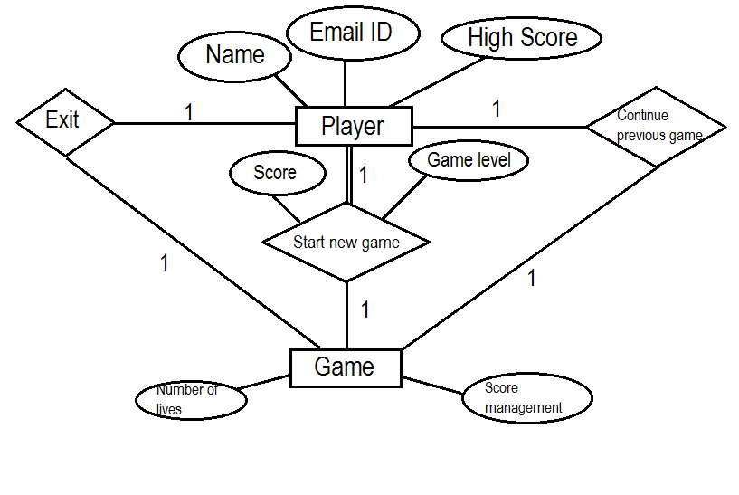

**3.6 Use Case Diagram**

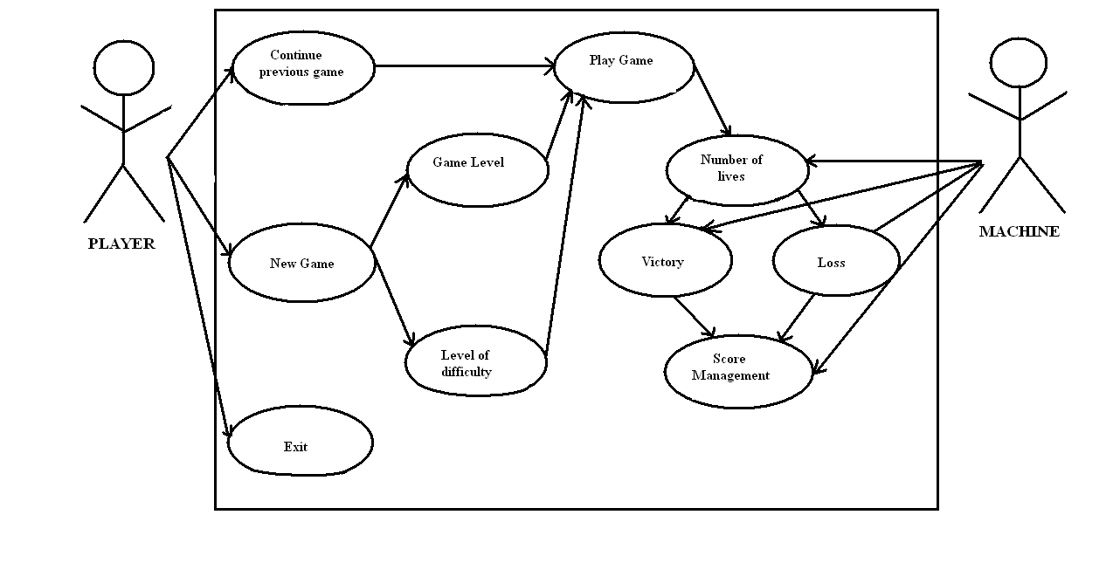

**3.7 Sequence Diagram**

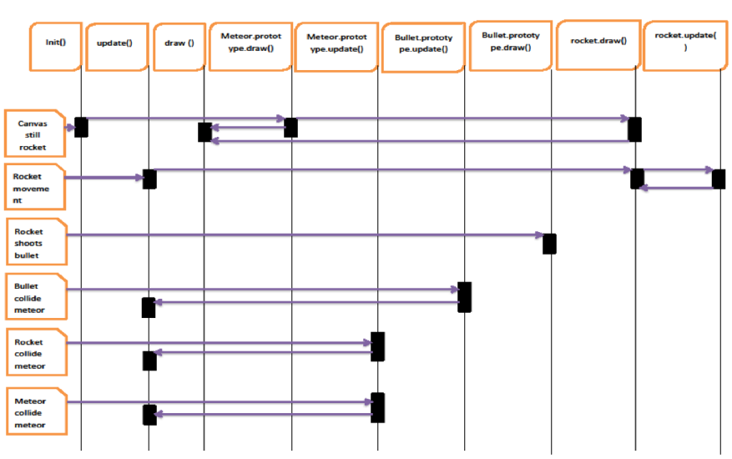

# **Overall Description**

## **4.1 Directory structure**

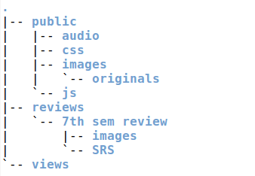

## **4.2 Product Functions**

* Meteor movement
  + Meteor.update : updates meteor coordinates
  + Meteor.draw : draws meteor on canvas
* Rocket movement
  + Rocket.update : updates rocket coordinates
  + Rocket.draw : draws rocket on canvas
* Bullet movement
  + Bullet.update : updates bullet coordinates
  + Bullet.draw : draws bullet on canvas
* Wrap around **-** Wraps around meteors and rocket

if (this.x > global.width) {

this.x = 0;

} else if (this.x < 0) {

this.x = global.width;

} else if (this.y > global.height) {

this.y = 0;

} else if (this.y < 0) {

this.y = global.height;

};

* Collision detection
  + Rocket & Meteors
  + Bullet & Meteors
  + Meteors
* Game audio - Audio for the game ( crash, explosions)
* Lives
* User Scoreboard **-** List of all scores

## **4.3 System interfaces**

## Asteroid integrates two internal systems to provide functionality:

## **Client** The game has an interface to the user’s client to receive user input and moves selections for the game.

## **Network** The game has an interface to the network in order to tansmit information.

## **4.4 Operating Environment**

The game needs an Internet browser that supports HTML5 and JavaScript to run, preferably Google Chrome.

V8is Google's open source high-performance JavaScript engine, written in C++ and used in Google Chrome. It ensures the JavaScript game engine runs at optimal speeds.

# **External Interface Requirements**

## **5.1 User Characteristics**

Asteroid is a very intuitive game and the only thing the user is required to know are the rules of the game, which are provided.

## **5.2 Hardware Interfaces**

Asteroid runs on any computer which meets the following criteria:

* Capable to use an Internet connection
* Includes memory storage
* Includes a mouse
* Includes a keyboard

## **5.3 Software Interfaces**

Requires an HTML5 and JavaScript enabled web browser.

# **Other Nonfunctional Requirements**

## **6.1 Performance Requirements**

The game is expected not to hang nor lag. The collision detection should be immediate.

## **6.2 Software Quality Attributes**

The game should be

* **Correct:** It should ‘just work’.
* **Flexible:** The user should be able to move, shoot, and carry out operations however he wants to. There will be no fixed movements.
* **Maintainable:** The code should be clean, modular, and adhere to standards.
* **Portable:** The game engine should be portable to any framework.
* **Reliable:** The physics behind the game must be reliable and work predictably. There should be no undefined results.
* **Testable:** The game engine should be easy to test; the code should provide for easy testing, deleting, etc.

1. **Implementation Details**

asteroid/

|-- config.ru

|-- development.db

|-- Gemfile

|-- Gemfile.lock

|-- LICENSE

|-- main.rb

|-- player.rb

|-- populate_db.rb

|-- public/

| |-- audio/

| |-- css/

| |-- images/

| | `-- originals/

| `-- js/

|-- README.md

|-- tasks.todo

`-- views/

**7.1 Routes:**

The game consists of various routes, each of which has a specific function.

* GET **/** - home page

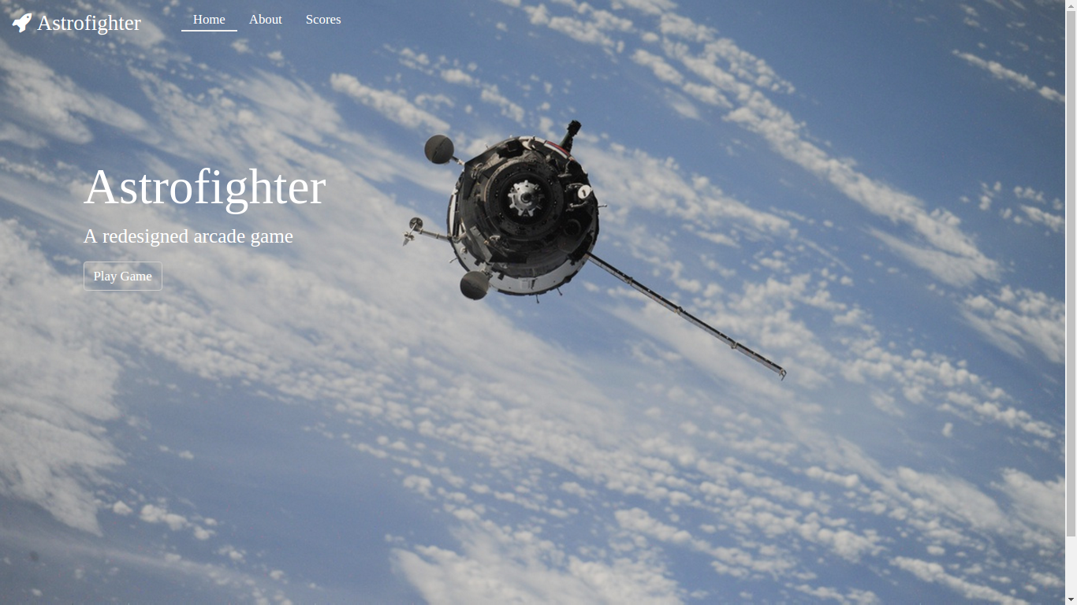

* GET **/about –** About page

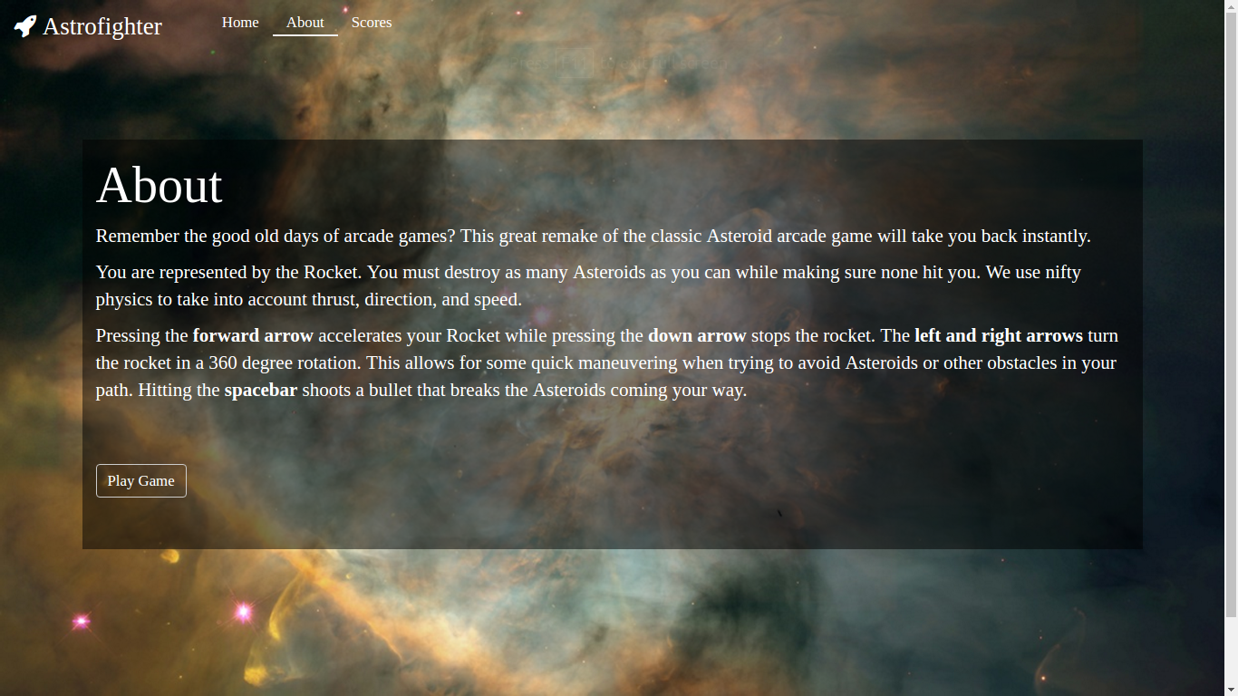

* GET **/game/?** - Game page

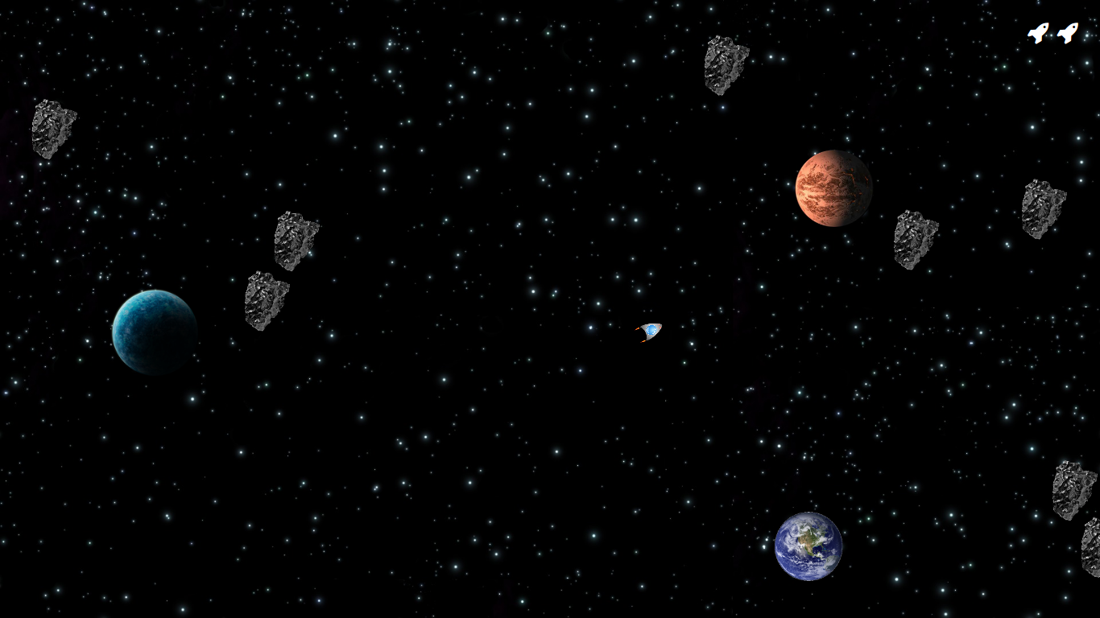

* GET **/gameover/?** - Game-over page. Enter use details

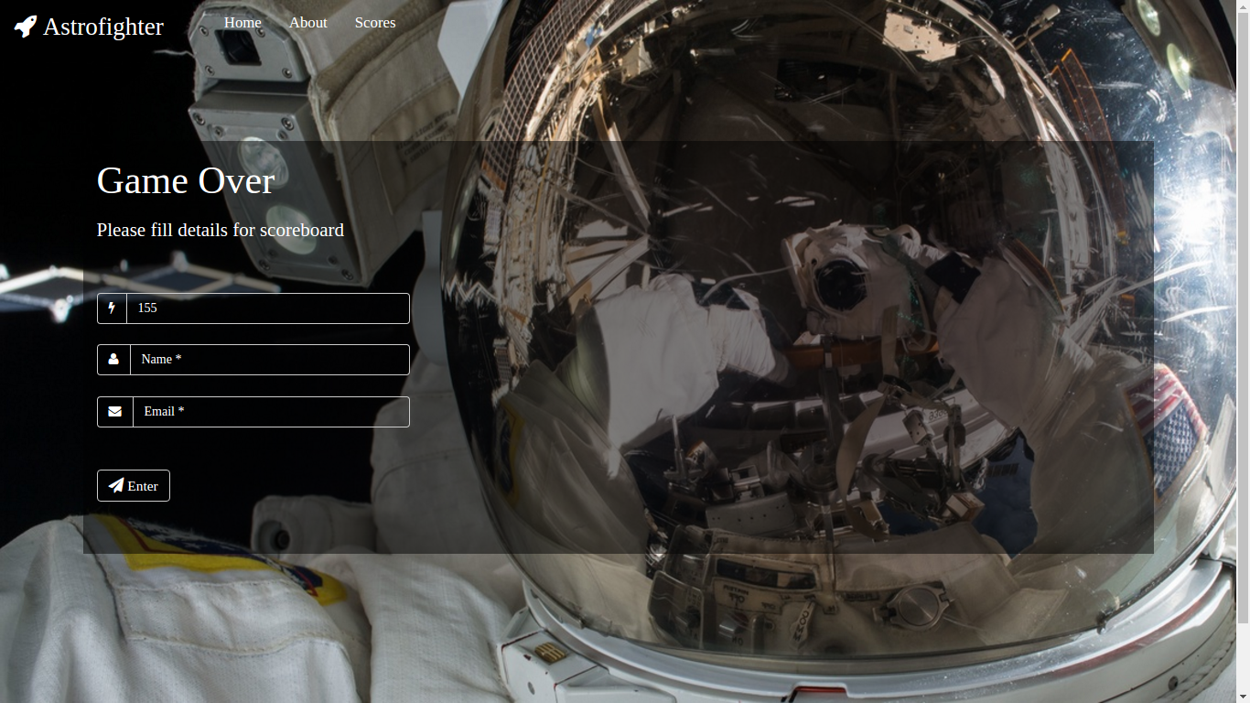

* GET **/scores** - Scoreboard page

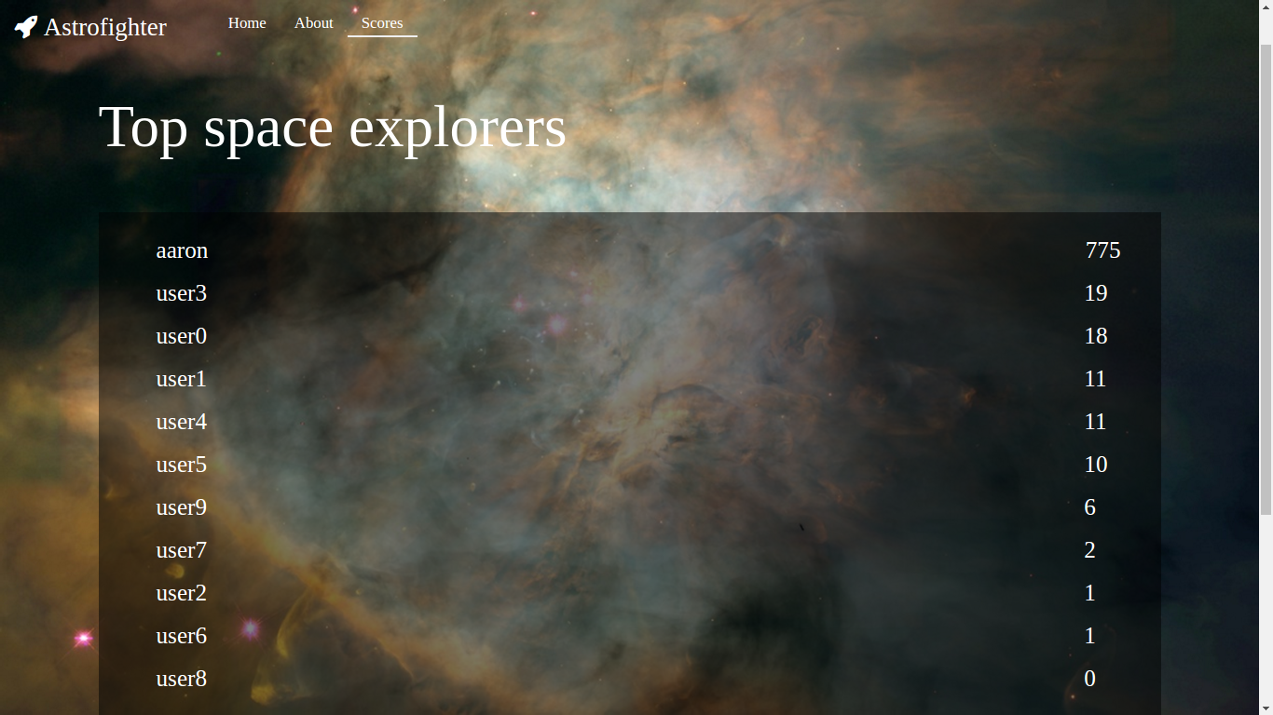

* **Not Found Page –** Broken Links

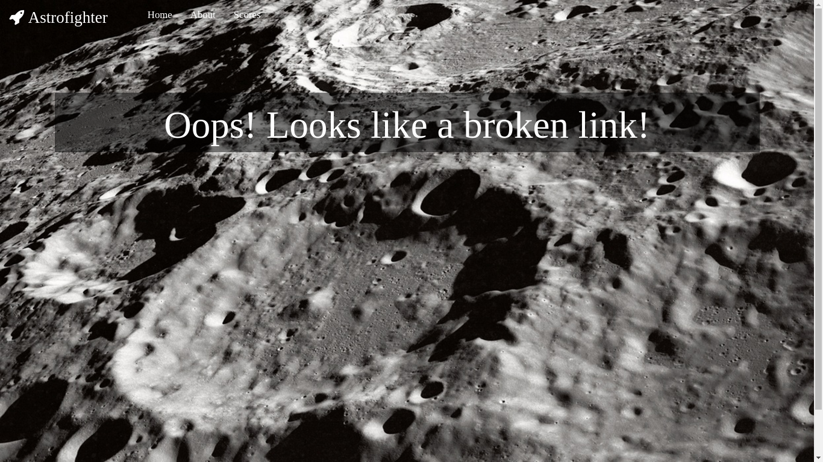

* **Server Error Page –** Unknown error on server side

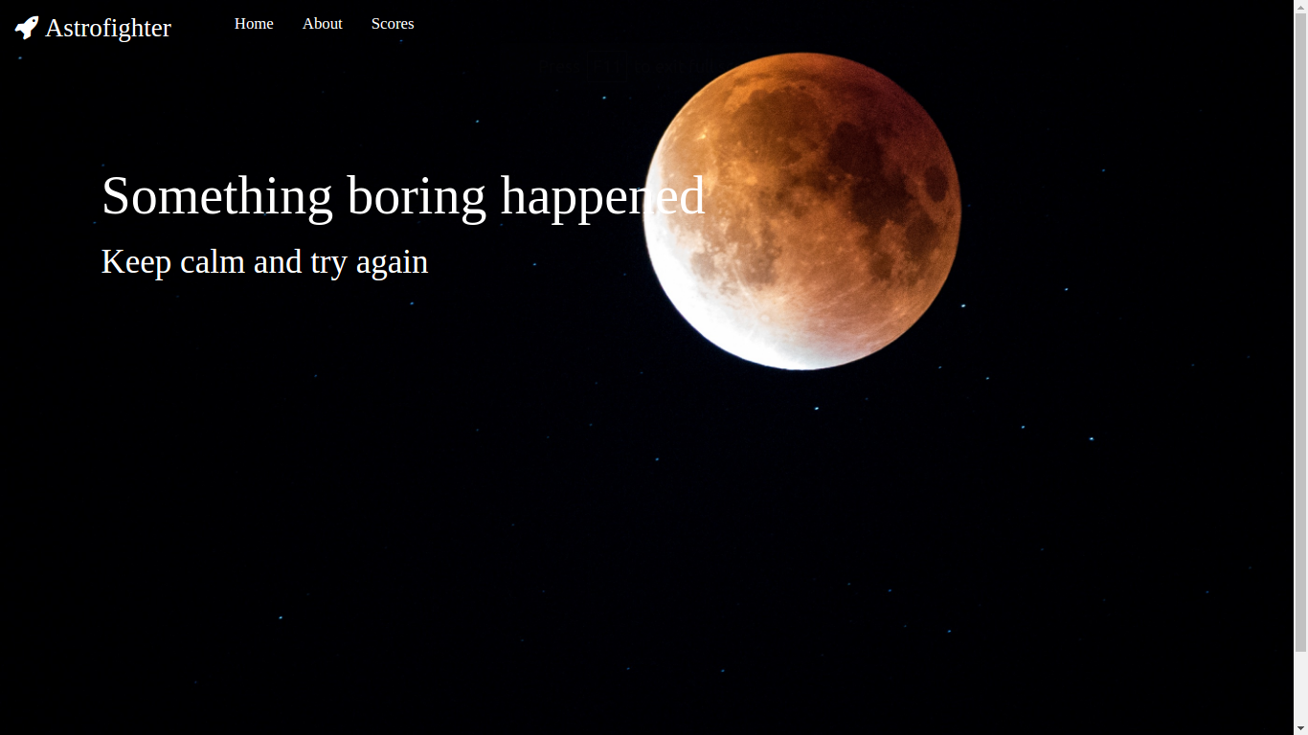

* POST **/players** -POST request route to update/add Player

**7.2 Views**

**ERB** (Embedded Ruby) is a feature of Ruby that enables you to conveniently generate any kind of text, in any quantity, from templates. The templates themselves combine plain text with Ruby code for variable substitution and flow control, which makes them easy to write and maintain.

ERB was used to generate the views for each of the routes.

views/

|-- about.erb

|-- error.erb

|-- game.erb

|-- game_over.erb

|-- home.erb

|-- layout.erb

|-- layout_head.erb

|-- nav.erb

|-- not_found.erb

`-- scores.erb

**7.3 Styles**

**CSS3** is the latest evolution of the Cascading Style Sheets language.

The views are styled using CSS3. The files are:

public/css/

|-- about.css

|-- error.css

|-- game_over.css

|-- home.css

|-- layout.css

|-- main.css

|-- not_found.css

`-- scores.css

**7.4 Player Class:**

The player class is defined as:

class Player

include DataMapper::Resource

property :id, Serial

property :email, String

property :name, String

property :score, Integer

end

**7.5 Audio**

Audio files are stored in /public/audio/

**7.6 Images**

Image files are stored in /public/images/

**7.7 Game Code**

**7.7.1 Objects**

* Rocket Object

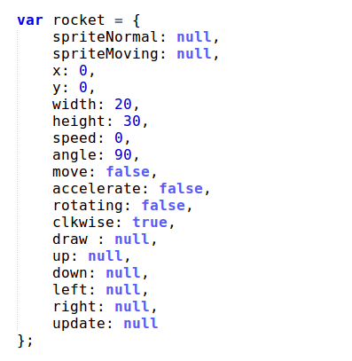

* Asteroid Object

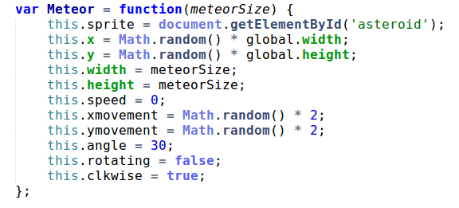

* Bullet Object

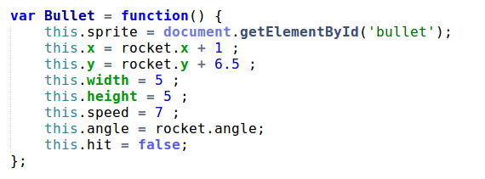

**7.7.2 Functions**

* Initialization Function

First function that is called. It initializes all the data we need.

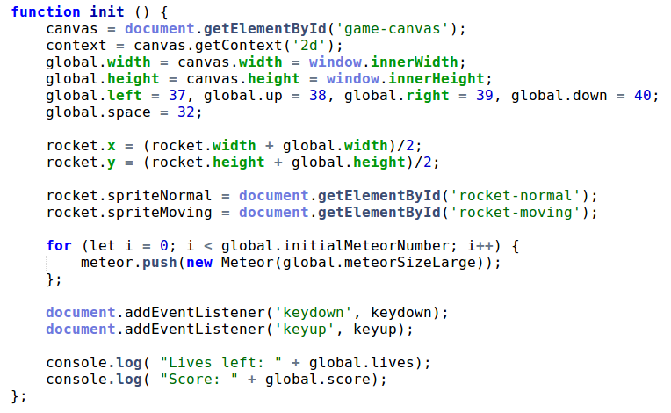

* Step Function

It is called 65 times a second by requestAnimationFrame. It calls global update and draw functions followed by a recursive call to itself. This form of recursion is called tail call optimization and ensures linear complexity without a stack.

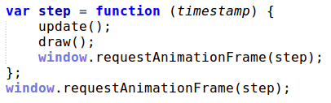

* Global Update Function

Calls the update function of each object.

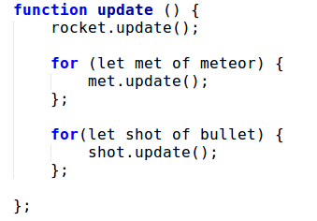

* Global Draw Function

Calls the draw function of each object.

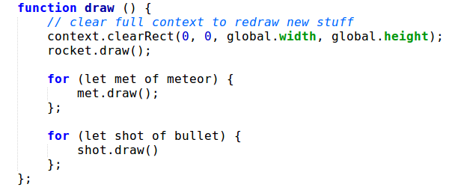

* Meteor – Draw & Update Functions

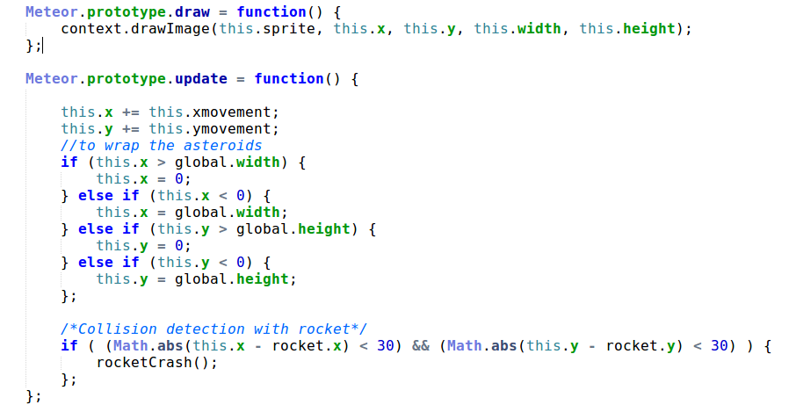

Each time the update function is called:

* It first increments the *x* & *y* co-ordinates of the meteor to show 'movement'.
* Then the co-ordinate positions are checked to determine if the meteor is moving out of context.
* If it is, the co-ordinates are updated so that the meteor wraps around and re-enters the context.
* Then it checks if a collision between the current meteor and the rocket has occurred.
* If collision has occurred it calls the *rocketCrash* function to decrement the number of lives and restart the game at initial position.
* The draw function draws the meteor sprite at the new updated position.
* Bullet – Draw & Update Functions(folded code)

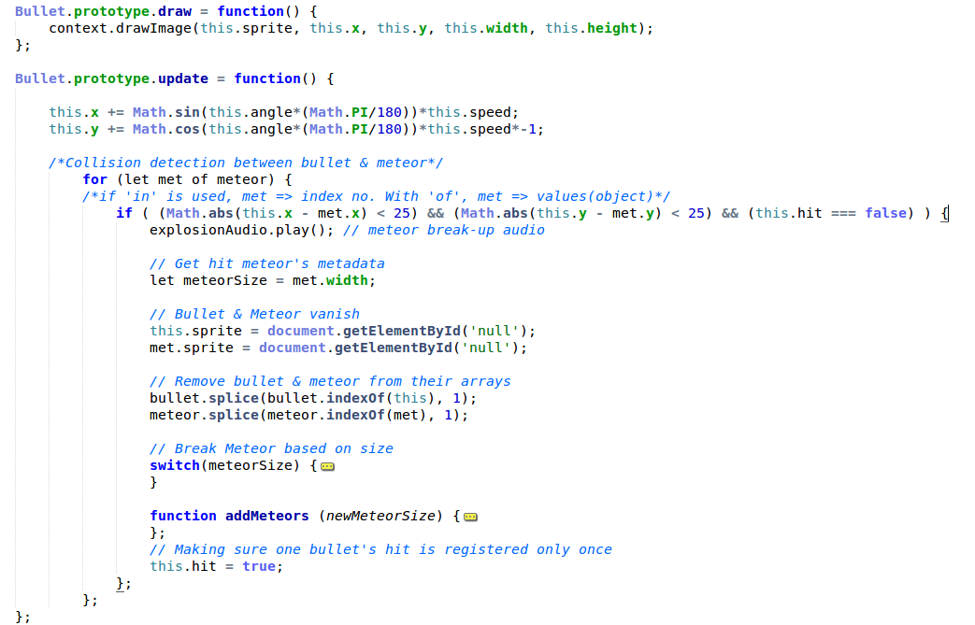

Each time the update function is called:

* It first updates the co-ordinates to emulate movement of the bullet.
* It checks if the bullet has collided with any of the meteors.
* If it has, the meteor is replaced.
  + Large meteor is replaced with Medium meteor.
  + Medium meteor is replaced with Small meteor.
  + Small meteors vanish when shot.
* The bullet vanishes after successful shot to ensure multiple hits are not registered.
* Rocket- Draw Function

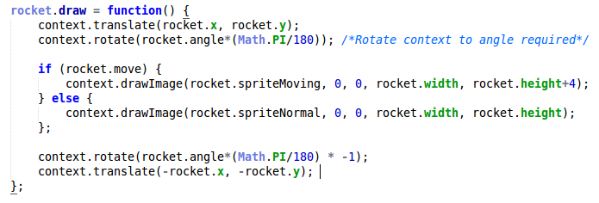

* The context is translated to the co-ordinates of the rocket. This places the context's origin at the center of the rocket.
* The context is rotated to the angle of the rocket in relation to the origin of the context.
* The rocket is drawn onto the context.
* The context is then rotated back to the normal orientation and translated back to it's original position.

Syntax for Context.drawImage

void Context.drawImage(image, sx, sy, sWidth, sHeight, dx, dy, dWidth, dHeight);

* + **dx** & **dy :** The X & Y coordinates in the destination canvas at which to place the top-left corner of the source image.
  + **dWidth** & **dHeight :** The width and height to draw the image in the destination canvas. This allows scaling of the drawn image. If not specified, the image is not scaled in width when drawn.
  + **sx** & **sy :** The X coordinate of the top left corner of the sub-rectangle of the source image to draw into the destination context.
  + **sWidth :** The width of the sub-rectangle of the source image to draw into the destination context. If not specified, the entire rectangle from the coordinates specified by sx and sy to the bottom-right corner of the image is used.
  + **sHeight :** The height of the sub-rectangle of the source image to draw into the destination context.
* Rocket – Update Function

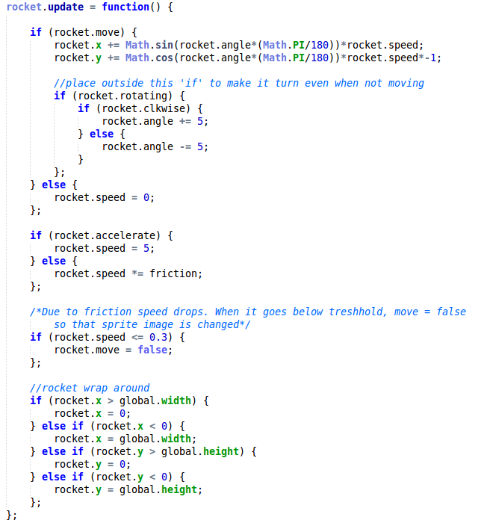

Each time the update function is called:

* The co-ordinates are updated to show motion of the rocket.
* The angle of rotation of the rocket is adjusted based on flag set by key-press listeners.
* The acceleration and speed is adjusted based on flags set by key-press listeners.
* Rocket wrap around is performed by checking co-ordinates *wrt* the context.
* Key Listener Functions

Listen for key presses to perform actions.

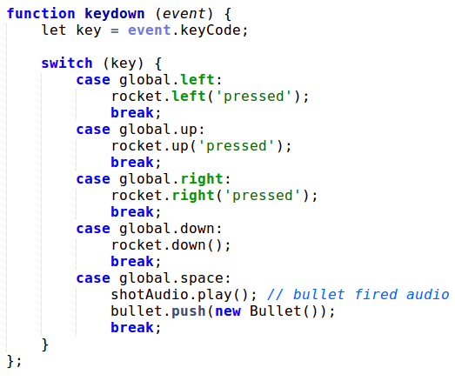

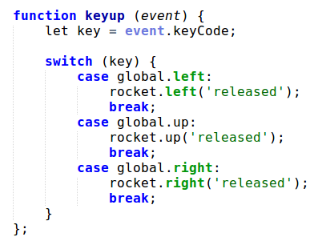

**7.7.3 Global Data**

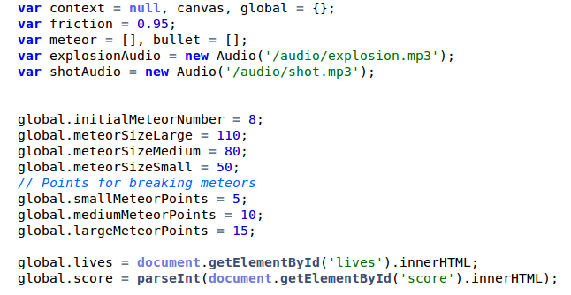

**7.7.4 Integrated Code**

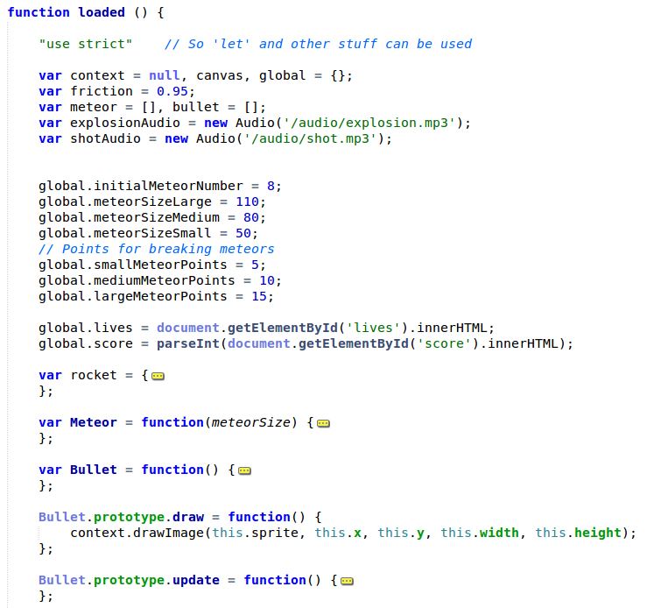

All the functions and objects integrate to form a single script.

* The code has been folded to ensure brevity.

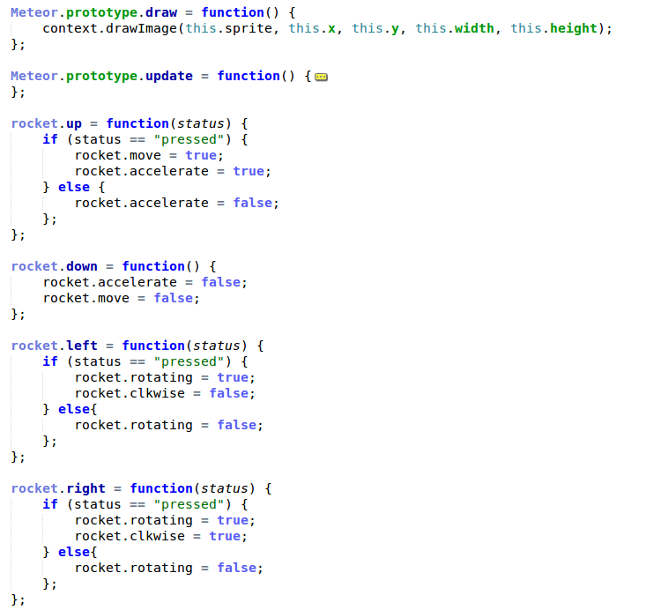

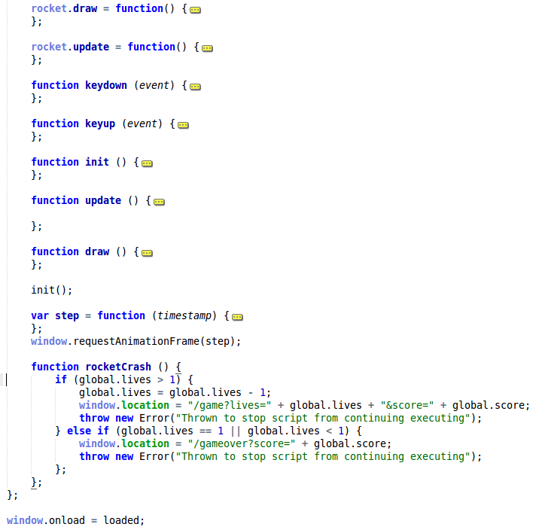

**7.8 Gemfile**

A Gemfile is a file we create which is used for describing gem dependencies for Ruby programs. A gem is a collection of Ruby code that we can extract into a “collection” which we can call later.

